Lab 10 Template

- Screenshot of ssh server active status
(5 points)

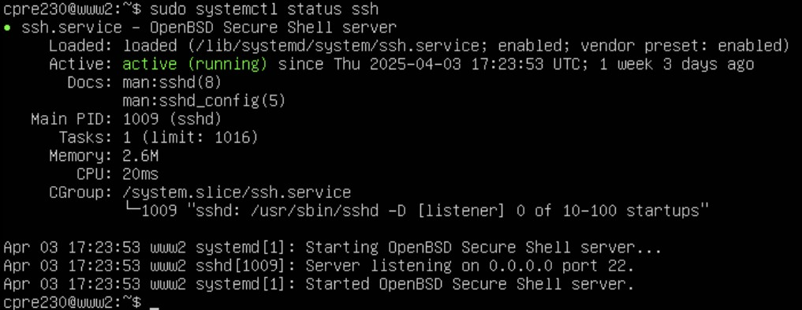

- Three potential services/options to configure. Why or why not configure them.
(10 points)

- Password Authentication: It allows the user to log in via entering a password and gives him the right to enable or disable the log in for anyone, so that’s why we should configure it. It must be set to no so that the SSH keys require stronger security to secure the information.

- Permit Root Login: It has the final call on whether the user should be allowed to log in via SSH or not, so that’s it should be configured and set to no, if we want to reduce risk of exploiting the remote root access.

- Port: It has the power to determine on which port the ssh server should listen on. The default port is 22.We must configure it because changing the port helps us to reduce the automated bot attacks.

- Screenshot of desktop ssh connection to www2
(5 points)

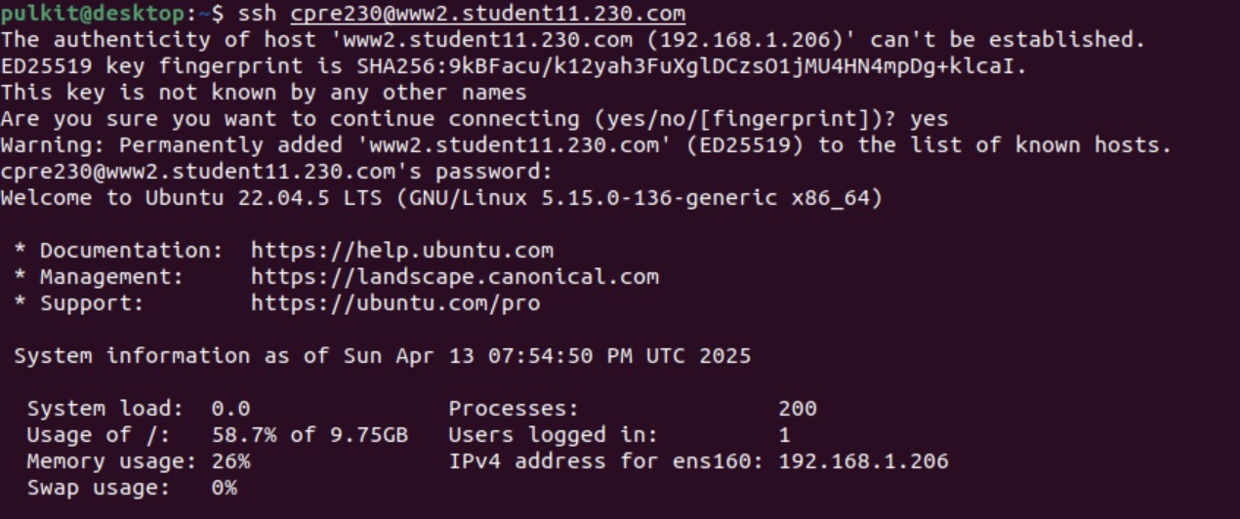

- Explain the purpose of the fingerprint and randomart image and when you would use them.
(10 points)

Ans) A fingerprint is basically just a short and unique representation of our public key and its main purpose is to let us verify a key visually or manually. We can use it when we are connecting to the ssh server for the very first time as SSH shows the fingerprint of the server so that we can confirm that we are using the right machine. It can also be used for verifying our public key securely as anyone can verify the fingerprint to ensure that the key wasn’t tampered by anything.

A randomart image is basically a representation of a fingerprint. Its main purpose is to help us in visually finding out if a key has been changed or not as it is designed to be human-readable. It can be used when we are comparing 2 ssh keys and it can also be used to visually verify the identity of our own keys without going through the full fingerprint.

- Screenshot of the public key.
(5 points)

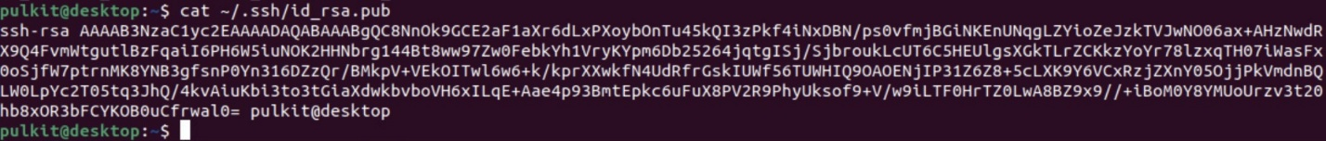

- Include a screenshot of your successful NAT rule for ssh on www2.
( 5 points)

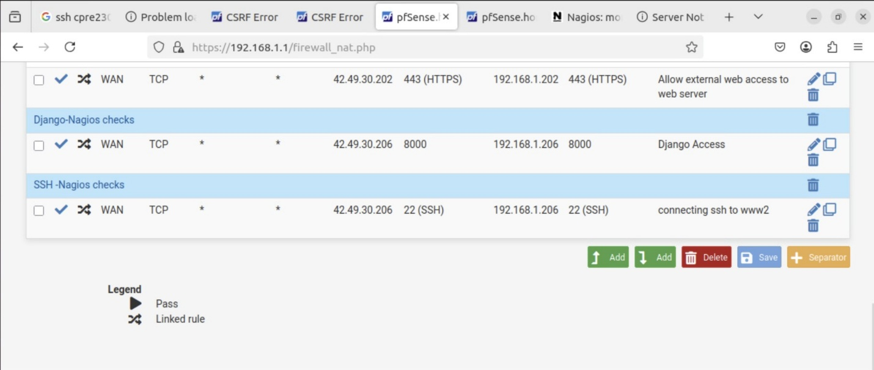

- Include a screenshot of the Nagios status showing ssh services are functioning on www2.
(5 points)

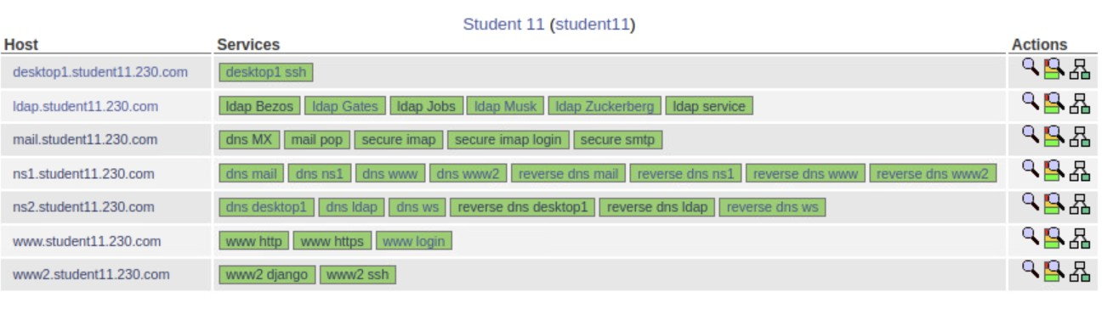

- Screenshot of the Nagios services for the desktop with it being red.
(5 points)

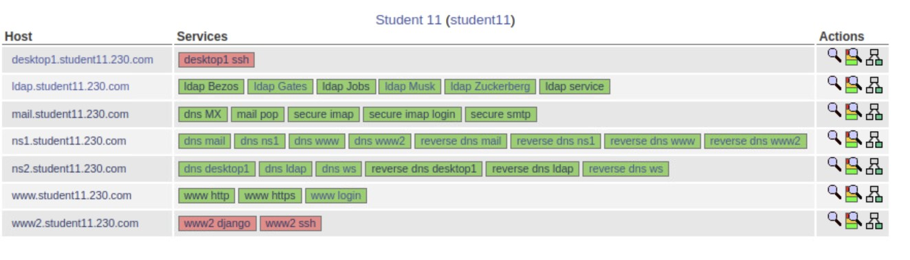

- Screenshot of UFW rules for desktop
(5 points)

- Screenshot of the Nagios services for the desktop turning green after UFW rules.
(5 points)

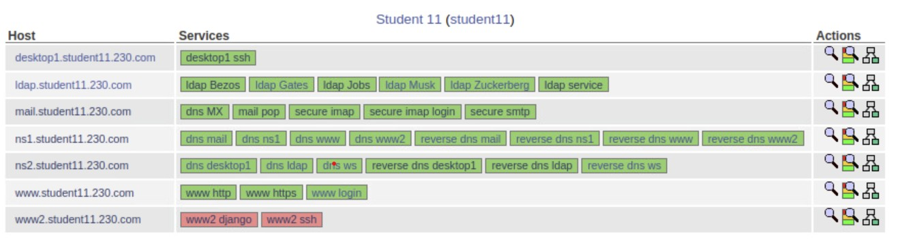

- Screenshot of UFW rules for ns2
(5 points)

- Screenshot of 6 additional sets of UFW rules (ns1, www, mail, ldap, www2, ws)
(20 points)

- Screenshot of successful LDAP query on partner's network.
(15 points)

